Advanced Scripting   
Help

Last Updated: 9/20/2021 3:52 PM Version 1  
Document Prepared for: CIT361 Student

# Name Ryan Skidmore ID 615907798

# Instructions

Save a copy of this document. Answer all questions directly in this document. You will save and upload this completed document as your homework submission.

# Overview

This exercise will provide practice setting up and using the PowerShell help system.

# Setup

## Requirements

* PowerShell
* Internet connectivity

# Task 1—Maintaining Help

Help is not installed by default in PowerShell. If you issue the get-help command for a command when there is no help on the system the output will contain the command name, the syntax, any aliases and in the remarks it will say that help is not installed on the system and will even provide commands to install help.  
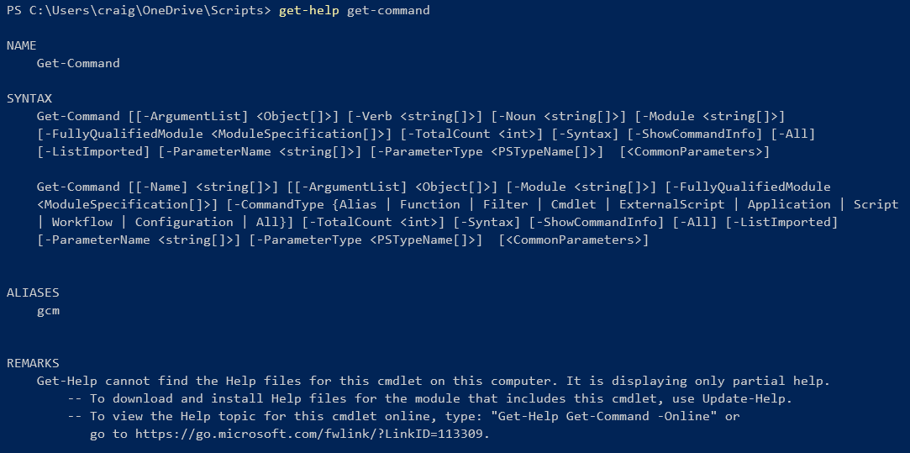

## Steps

1. Update help on your system.
   1. Start an administrative PowerShell shell.
   2. Enter the command   
      Update-Help
   3. After a few minutes, help should be installed.

# Task 2—Getting help on a command

Using Get-Help to get help on commands

## Steps

1. Get-Help for Get-Process. To get help on a specific command use the -name parameter of Get-Help. E.g.  
   Get-Help -Name Get-Process  
   or (using positional parameters)  
   Get-Help Get-Process
   1. From the help DESCRIPTION what does Get-Help do without any parameters?  
      Displays information about PowerShell commands and concepts
2. Sometimes it is easiest to learn how to use a command by seeing an example. The -Examples parameter shows examples of how to use the command. Enter the command:  
   Get-Help Format-Volume -Examples
   1. What does the Format-Volume command do? Formats one or more existing volumes or a new volume on an existing partition.
   2. How many examples are given? 2
3. The -Full parameter lists all the help available. Use the -Full parameter on Get-Help for the Get-Help command and answer the following questions.
   1. What does the -Detailed Parameter do? Gives a detailed explanation of command.
   2. What does the -Online Parameter do? Opens a webpage that explains the process
   3. What does the -Path parameter do? Full and relative path name formats in powershell
   4. What other words can you use to get-help? ?, about_modules, remoting

# Task 3—Getting Help on a Topic

The help system also contains help on topics that are not cmdlets.

## Steps

1. To get help on topics rather than cmdlets use a the text “about_” in front of the name. To get help on the -split operator enter the command:  
   Get-Help about_split
   1. From the help file answer the following questions:
      1. What does -split do? Splits string(s) into substrings
      2. Give and example of using split? "This.is.a.test" -split ".", 0, "simplematch"

# Task 4—Finding help topics.

You can use the help system to search for help topics as well.

## Steps

1. You can use wildcards in the name to allow pattern match searches. To get a list of all help topics, enter the command:  
   Get-Help *
2. To get a list of topic help files, enter the command:  
   Get-Help About_*
3. Use help to learn about wildcards. Enter the command:  
   Get-Help About_Wildcards  
   What wildcards does PowerShell support? *, ?, [ ]
4. Finally, if you get help on a word that is not a help topic, the help system will look through all help topics and return the topics that contain that word. Enter the command:  
   get-help hklm
   1. What is first topic returned? ConvertFrom-SddlString
   2. What is the last topic returned? About_Remote_Troubleshooting

# Deliverable

Upload this document with completed answers to i-learn.